Documented changes:

Start

Imported starter greybox 2.5D scene.

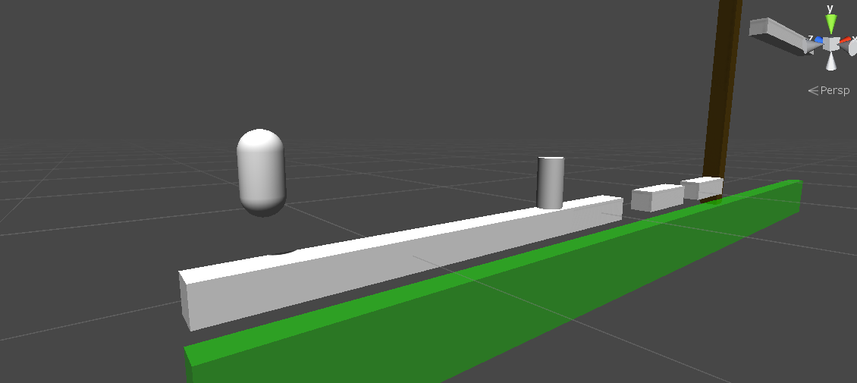

19/05/2019

Smoothed out movement with Slerps and cleaned up unnessesary functions and made movement more free

Changed movement to Lerps for smoother movement

Created smooth following camera script

Added greybox meshes and added onto player script for head and arms to face the mouse

Corrected a Quaternion LookRotation issue that caused sudden changes in rotation to affect other axis of rotation.

Smoothed out Look rotation

Added a bool to correct incomplete orientation switching

Successfully added animation for the head, body and legs

Implemented chargeable punches

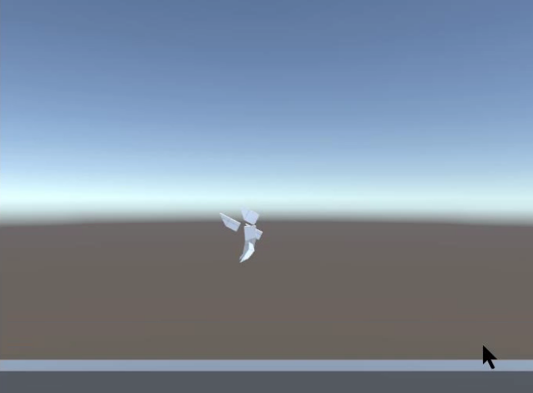

23/05/2019

Widened hurtbox

Added variations of displacement per punch

Make the collision boxes toggle during each punch

Collision script for each fist, player script communicates with each fist to determine the recoil and damage

Added player damage, enemy health, vertical only punch recoil

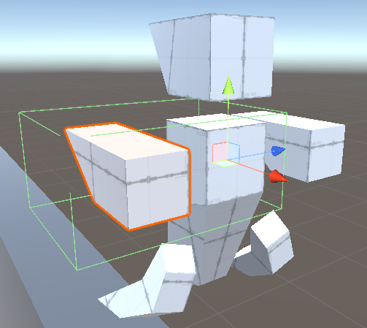

24/05/2019

Implemented enemy flinching

Finished recoil

Added enemy death animation and fixed bug concerning how hitting the enemy’s detection range counts as a hit.

Made camera zoom out depending on the recoil intensity

Added enemy damage and player health.

Added player death and autoreload.

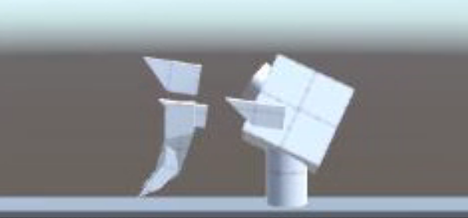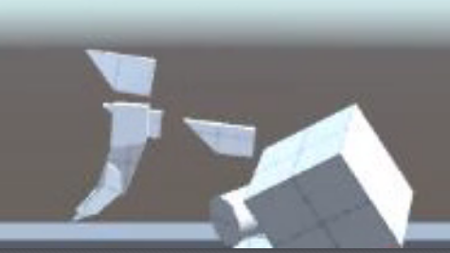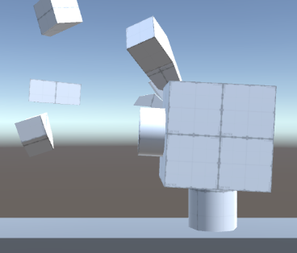

25/05/2019

Assembled the basic shape of the Greybox map

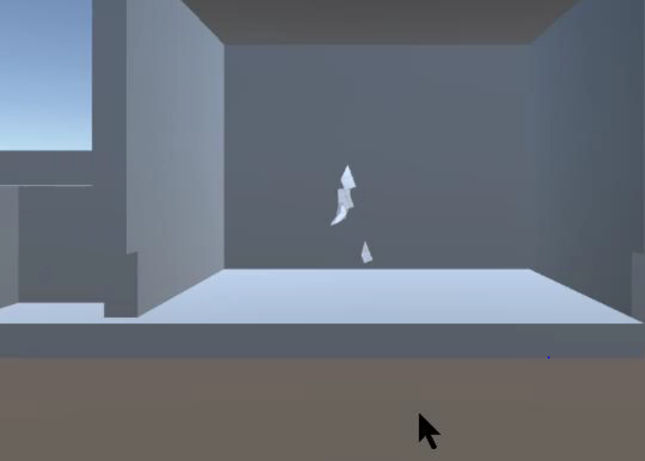

26/05/2019

Added Materials

Added particle effects for power swings

Added particle effects for power hit collisions

Added the other enemy type, Sideways collision detection cannot be fixed.

Added locked doors and assembled more of the greybox map

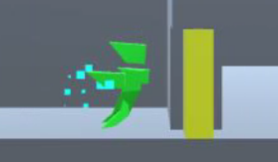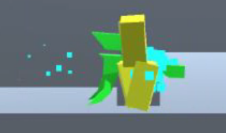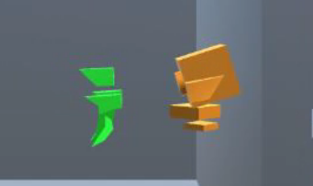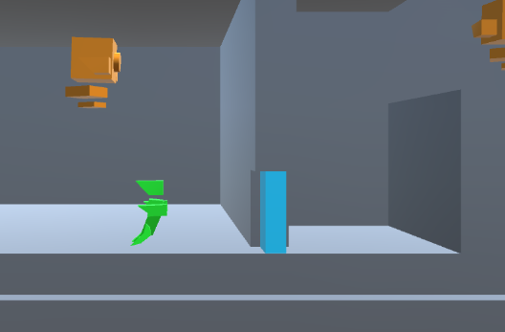

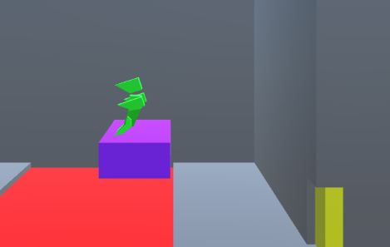

27/05/2019

Attempted to install HD pipeworks and added Dissolve shader.

Reverted due to lag.

Started working on GreyboxMiniboss

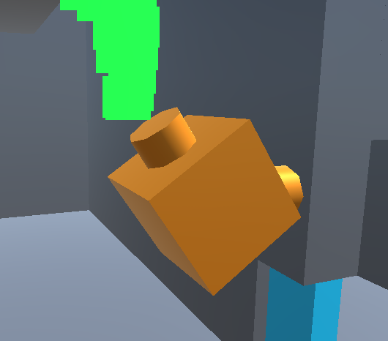

3/06/2019

Finished Miniboss

Finished the greybox map with hidden secret

Received feedback by Craig Bentick about the 27/05 version:

* Must make character have Zero Vertical velocity as soon as the top of the character collides with the roof.
* Windup and release timing requires minor adjustments.
* Overall Great.

Fixed the issue of the player sticking to the ceiling

Added the UI for progress bar, objective text, placeholder chat bar, placeholder pause.

Added the enemy health bars, Charge bar, Speed bar, scripted the health bar.

